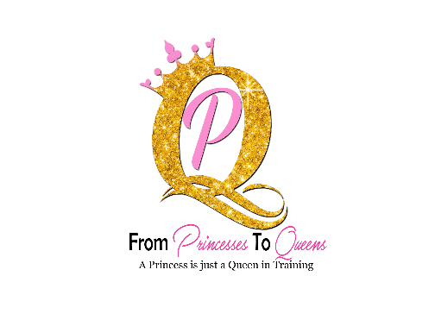From Princesses to Queens Volunteer Application

Application Date ________________
Volunteer Position Sought _______________________________________________________
Name ________________________________________________________________________
Home Address _________________________________________________________________
Work Phone ___________________Home Phone _____________________________________

EDUCATION
Highest Level of Education ________________________________________________________

EMPLOYMENT
Current Employer, if applicable:
Position/Title __________________________________________________________________
Dates of Employment (starting, ending) _____________________________________________
Company/Employer _____________________________________________________________
Address _______________________________________________________________________
Would you like us to keep your employer abreast of your volunteer service and achievement? No Yes

SKILLS & EXPERIENCE
Special training, skills, hobbies _____________________________________________________
Groups, clubs, organizational memberships __________________________________________
Please describe your prior volunteer experience (include organization names and dates of service) _______________________________________________________________________
______________________________________________________________________________
______________________________________________________________________________
______________________________________________________________________________
______________________________________________________________________________
What experiences have you had that may prepare you to work as a volunteer in the field of [description of field, e.g., domestic violence, child abuse prevention, youth recreation, etc.]? ______________________________________________________________________________
______________________________________________________________________________
______________________________________________________________________________
______________________________________________________________________________
Why do you want to volunteer? [Or, What do you want to gain from this volunteer experience?]
______________________________________________________________________________
______________________________________________________________________________
______________________________________________________________________________
Have you ever been convicted of a crime? [If yes, please explain the nature of the crime and the date of the conviction and disposition.] Conviction of a crime is not an automatic disqualification for volunteer work.
______________________________________________________________________________
______________________________________________________________________________
What makes you different? What drives you?
______________________________________________________________________________
______________________________________________________________________________
What does the term “Queen” mean to you? How would you explain its meaning to a six grader?
______________________________________________________________________________
______________________________________________________________________________

Do you have a driver’s license? No Yes
Do you have car insurance? No Yes
Do you have a car available for transporting others? No Yes

REFERENCES
Please list three people who know you well and can attest to your character, skills, and dependability. Include your current or last employer.

Name/Organization | Relationship to you | Length of relationship | Phone number

Please read the following carefully before signing this application:
I understand that this is an application for and not a commitment or promise of volunteer opportunity. I certify that I have and will provide information throughout the selection process, including on this application for a volunteer position and in interviews with From Princesses to Queens that is true, correct and complete to the best of my knowledge. I certify that I have and will answer all questions to the best of my ability and that I have not and will not withhold any information that would unfavorably affect my application for a volunteer position. I understand that information contained on my application will be verified by From Princesses to Queens. I understand that misrepresentations or omissions may be cause for my immediate rejection as an applicant for a volunteer position with From Princesses to Queens or my termination as a volunteer.
Signature __________________________________________ Date _________

